RECIPE  
Chipotle Sauce for Fish/ Shrimp Tacos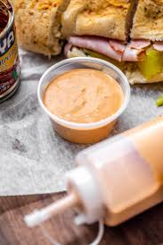

# Ingredients

* ¾ cup mayo
* 2 tbsp lime juice
* 2-3 chipotle chiles
* Large garlic

# Preparation

1. Mix ‘em all together. That’s right, it’s that easy :)